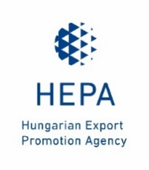 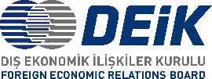

**3RD TURKISH-HUNGARIAN GO AFRICA BUSINESS FORUM**

**Budapest, 3 March 2022**

**Language**: English, Hungarian, Turkish and Arabic simultaneous interpretation

**Location:** Kempinski Hotel Corvinus Budapest, 1051 Budapest, Erzsébet tér 7-8.

**Moderator:** Edit Szalai

**PROGRAM**

|  |  |
| --- | --- |
| 60 minutes | Registration of participants |
| 20 minutes | **Welcoming addresses** *Language: English, Hungarian, Turkish, Arabic*  **Dr. Kristóf SZABÓ,** *Chief Executive Officer of Hungarian Export Promotion Agency (HEPA)*  **Mr. Mr. Adnan Sezgin***, Chairperson, DEİK/Türkiye-Hungary Business Council*  **Mr. Mehmet Erdal EREN,** *President of Turkish Contractors Association (TCA), Vice President of Foreign Economic Relations Board (DEİK)* |
| 30 minutes | **Opening remarks** *Language: English, Hungarian, Turkish, Arabic*  **H.E. Mr. Péter SZIJJÁRTÓ,** *Minister of Foreign Affairs and Trade of Hungary*  **H.E. Mr. Mehmet MUS,** *Minister of Trade of Turkey*  **H.E. Sheikh Mohammed bin Abdulrahman AL-THANI,** *Deputy Prime Minister and Minister of Foreign Affairs of Qatar* |
| 20 minutes | Break |
| 60 minutes | **Presentations -** *Language: English*  **Mr. Alassane BA**, *Chief Executive Officer at African Development Bank (AfDB) (TBC)*  **Mr. Gergely JÁKLI**, *Chief Executive Officer at EXIM Hungary*  **Ms. F. Zehra TÜRKÖZ SAYAR**, *Head of Department of*  *International Loans and Relations at Türk EXIMBANK*  **H.E. Albert MUCHANGA,** *Commissioner at the African Union*  **Company and Project Presentations -** *Success stories (1 Hungarian and 1 Turkish)* |
| 90 minutes | **B2B meetings** *(Language: English, interpretation is not provided)* |